Differentiated instruction (DI) is a process by which teachers get to know their students so that they can accommodate them in learning.
The term Universal Design for Learning (UDL) is a framework used for education purposes that provides flexibility and decreases barriers in learning environments. This is done by providing a variety of ways for students to access, engage, and respond to content.
While DI and UDL are similar, they are not the same thing. Below you can find more information and helpful links on DI and UDL, as well as some of the similarities and differences between DI and UDL.
Universal Design for Learning (UDL)
The Three Principles of UDL:
Principle I: Provide Multiple Means of Representation (the “what” of learning)
Principle II: Provide Multiple Means of Action and Expression (the “how” of learning) Principle III: Provide Multiple Means of Engagement (the “why” of learning)
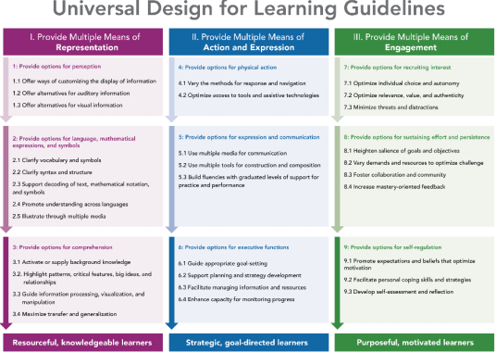
© CAST, 2015
CAST
CAST is a nonprofit education research and development organization that works to expand learning opportunities for all individuals through Universal Design for Learning. On their website you can learn more about this organization, the research they are doing, and how you can get involved.
National Center on Universal Design for Learning
The National Center on Universal Design for Learning offers a wealth of information on UDL. By visiting their website you can learn more about UDL guidelines and research. There are also many resources for both teachers and parents. In fact, they even have an iTunes app called UDLinks that allows parents and teachers to access content specific resources on their mobile devices.
UDL in the Middle School Science Classroom
This article presents information on research done in four middle school science classrooms to find the effectiveness of using UDL in instruction compared to the regular curriculum that does not follow UDL guidelines. While this study did not show an increase in posttest scores when using the UDL guidelines, it did find that the UDL-aligned units were more effective in increasing student engagement and providing students with multiple ways of expressing themselves.
Mini Anchors: A Universal Design for Learning Approach
This article takes a look at a concept that was developed based on the UDL guidelines in order to help students with math using a technology-based system that provides support based on the students needs. This math system creates a way for a diverse group of learners to access information, and these concepts could potentially be applied to other subjects.
Differentiated Instruction (DI)
What is Differentiated Instruction?
This article by Laura Robb takes a more in depth look at DI and its benefits. Some of the information covered includes taking a look into a classroom where DI is implemented and practices that can be used to differentiate instruction.
The four main components for differentiating instruction are content, process, product, and affect/environment.
Ways to differentiate content:
• Audio Books / lessons
• Graphic Organizers
• Note-taking Organizers
• Varied levels of texts
• Various supplementary materials
• Adjusting proximity of ideas to student experience(s)
• Reading Partners / Reading Buddies
• Choral Reading
• Think-Pair-Share
• Small groups to reteach or extend
Ways to differentiate the process of learning:
• Choices of text, tasks, and partner(s)
• Interest Centers/Zones/Workstations
• Tiered lessons and activities
• Learning contracts: personal agendas
• Hands-on activities/manipulatives
• Varied time to complete tasks
• Varying how much support we provide each child by how much they need
• Presenting learning through different means. e.g., audio/visual – vary text size, color contrasts. • Using graphic organizers, concept maps, or charts.
• Working with outside support to accommodate students - such as special education teachers or reading specialists
Ideas for differentiating products:
• Providing expectations that allow for varying degrees of difficulty, meaning, and procedures • Providing rubrics that are developed based on varying skill levels
• Working alone or in small groups on different “products” e.g., giving a speech, creating a model, create a flyer
• Encouraging creation of individual products that contain “aspects” of the assignment • Varied time to complete tasks
Ideas for differentiating affect in the classroom and/or environment:
• Asking, “Where do you do your best thinking?”
- Is it a quiet place or a crowded place?
- A small space or a big place
• Establishing routines that are so consistent that they almost become tangible
• Creating a positive learning environment by incorporating materials that encourage student collaboration • Including structured guidelines so that students are more comfortable in familiar settings. • Asking, “Where do you do your best learning?”
- In a "homey" place - on pillows, in a tent.
- On the floor or in a chair
- In a structured place

