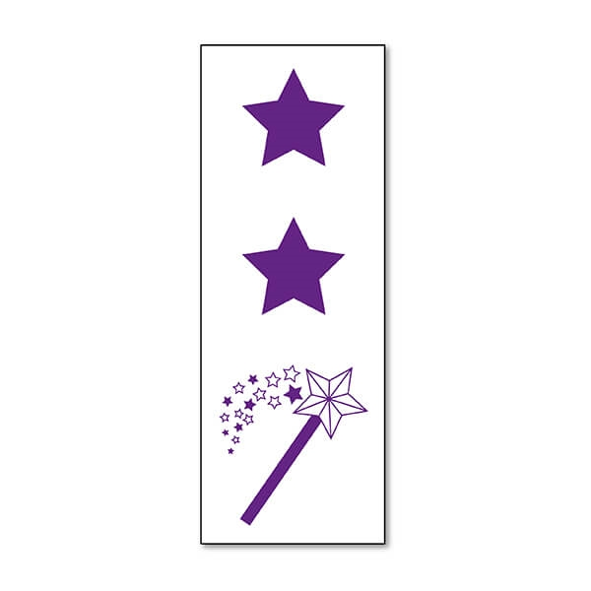
Peer Assessment: 2 Stars & 1 Wish Presentation Number: _____

________________________________________________________________________________________________________________________________________________________________________

________________________________________________________________________________________________________________________________________________________________________

________________________________________________________________________________________________________________________________________________________________________

Peer Assessment: 2 Stars & 1 Wish Presentation Number: _____

________________________________________________________________________________________________________________________________________________________________________

________________________________________________________________________________________________________________________________________________________________________

________________________________________________________________________________________________________________________________________________________________________

Peer Assessment: 2 Stars & 1 Wish Presentation Number: _____

________________________________________________________________________________________________________________________________________________________________________

________________________________________________________________________________________________________________________________________________________________________

________________________________________________________________________________________________________________________________________________________________________

