CRECER Executive Summary
2018 - 2019

Challenging Racism & Empowering Communities

through Ethnocultural Research

• • •

Derived from the Spanish word "crecer," meaning "to grow," the Challenging Racism & Empowering Communities through Ethnocultural Research (CRECER) team is a community-based participatory research team within the Department of Educational and Psychological Studies at the University of Miami committed to social justice for ethnic minorities and immigrant populations through academic research and community intervention and engagement.
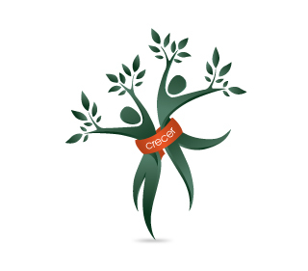

Table of Contents
Meet the Team 2
Dr. Guerda Nicolas 3
Message from the Director 3
Monique C. McKenny 4
Esprene Liddell-Quintyn 4
Marisol Meyer 5
Ceewin N. Louder 5
“Maxie” Ashley Maxie-Moreman 6
Dorothy Addae 7
Noris Rio 7
Dr. Amina Y. Simmons 8
Dr. Kimberly Ho Misiaszek 9
Contact Us 9
Program Updates 10
Strong Roots Parenting Program 11
Kulula Mentoring Program 14
Day of Dialogue 21
Selected Articles and Books from the CRECER Lab 25

Meet The Team

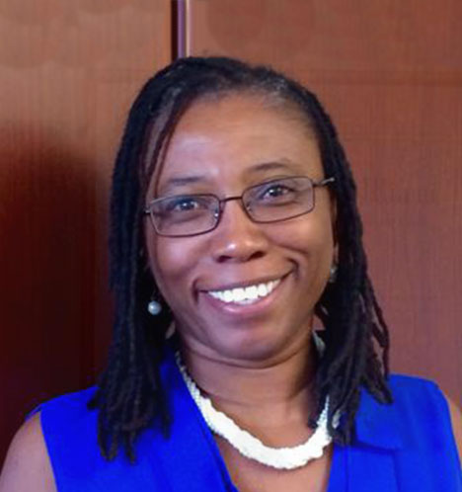
Guerda Nicolas, PhD
Message from the Director
Dear Readers,
This issue of the Executive Summary highlights the work accomplished by the CRECER research team in collaboration with our community partners in Miami and in Haiti.
The values of CRECER are that we should not produce knowledge simply for knowledge sake, but to ensure that the work we do is meaningful for the communities and the people with whom we work. We value the resources and strengths of all our partners who make the work that we do possible and sustainable. Therefore, the summaries of the work highlighted here are more of a reaction of their efforts than of ours.
As we are attempting to cope with the number of troubling social issues occurring in communities throughout the US, we hope that our community partnerships that seek to build the identity and family systems of people of color are making a difference.
Thank you to our community partners and to the foundations who continue to support our work both nationally and internationally. We look forward to another great year of programming in the 2019-2020 year!
Sincerely,
Dr. Guerda Nicolas

Dr. Guerda Nicolas joined the Department of Educational and Psychological Studies at the University of Miami in August 2008 and the past the Chair of the Department. She was an Associate professor at Boston College in the Department of Counseling, Developmental, and Educational Psychology prior to joining the EPS faculty. She obtained her doctoral degree in clinical psychology from Boston University. She completed her predoctoral training at Columbia University Medical Center and her postdoctoral training the New York State Psychiatric Institute/Columbia University, Department of Child Psychiatry.
As a multicultural (Haitian American) and multi- lingual psychologist (Spanish, French, and Haitian Creole), her research is reflective of her back- ground and interests. She is a licensed psychologist and was the Assistant Director of the Institute for the Study and Promotion of Race and Culture (IS- PRC) along with Dr. Janet E. Helms.
Her current research centers on partnering with ethnically diverse and immigrant communities to develop culturally effective mental health interventions to combat depression, address issues of racism and racial discrimination stress, enhance the racial and ethnic identity development of children and adolescents, and promote individual, family, and community well-being.

Active Team Members

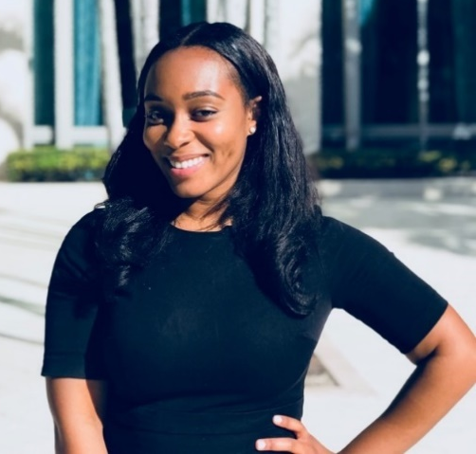
Monique C. McKenny,
M.S.Ed.
Monique McKenny is a third year PhD student at the University of Miami within the School of Education and Human Development. She earned a masters’ degree from the University of Pennsylvania in Counseling and Mental Health Services and her bachelor’s degree in Psychology from The George Washington University. Presently, she is completing a practicum year at Mailman Center for Child Development at the University of Miami Miller School of Medicine.
Monique seeks to use mixed methods to explore the content and process of racial coping practices among Black youth and families. She is interested in how experiences with racial discrimination relate to both psychological and neurobiological outcomes for Black youth as well as how methods of racial coping, specifically, racial socialization, can mitigate deleterious outcomes from these incidents. She was awarded the Spouses Education Scholarship from the Congressional Black Caucus and received Honorable Mention from the Ford Foundation Predoctoral Fellowship program. She currently serves as coordinator for Strong Roots, a parenting program for Black caregivers in the West Grove community of Miami.
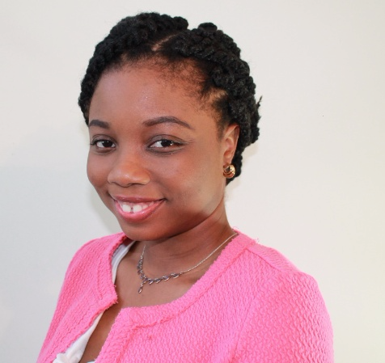

Esprene Liddell-Quintyn
M.A.
Esprene Liddell-Quintyn is a doctoral student in the Community Well-Being program at the University of Miami. She earned her bachelor’s degree at the University of Guyana and her master’s degree at Penn State Harrisburg. Before joining, the CRECER team, Esprene provided compassionate care and assistance to women with mental health challenges and supported research and organizational development initiatives at non-governmental organizations.
Her research focuses on examining intimate partner violence (IPV) within the Caribbean and among Caribbean immigrant women. She plans to design prevention and intervention programs, build community social capital and foster individual efficacy to combat IPV. Esprene is also interested in examining the acculturation and mental health experiences of Caribbean immigrant women. As a member of the CRECER team, Esprene will serve as the coordinator of Day of Dialogue and co-chair of the CRCP 2020 Early Scholars Committee.

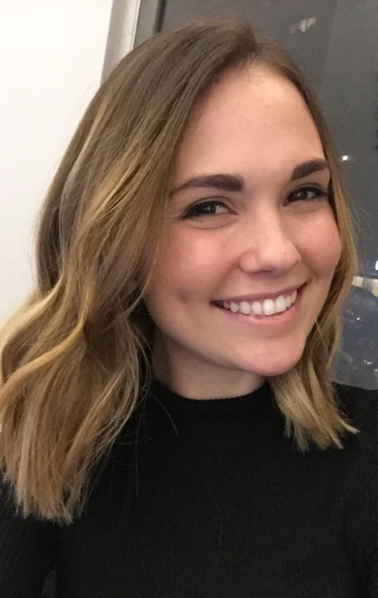
Marisol Meyer,
B.A.
Marisol is a second-year doctoral student in the Counseling Psychology program at the University of Miami. She completed her undergraduate studies at Dartmouth college in 2018, where majored in both Psychology and in Anthropology.
She is excited to be a part of the CRECER team and serve as a co-coordinator in the Kulula Project. Currently, her primary research interest is the development of social and emotional intelligence, skills, and competencies in ethnically diverse youth. Additionally, Marisol is interested in research focusing on the creation and implementation of intervention programs to promote positive mental health outcomes for multicultural, ethnically diverse, immigrant, and underserved populations. She is also passionate about working towards closing the research to practice gap and works towards making information gained via research accessible to all individuals.

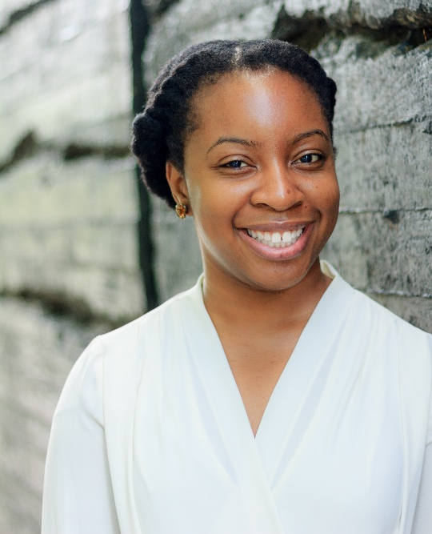
Ceewin N. Louder,
M.A.
Ceewin is a first-year doctoral student in the Counseling Psychology program at the University of Miami. She completed her undergraduate studies in Psychology and Biology at the University of North Carolina at Chapel Hill. After two years working as a missionary for the United Methodist Church and one year working as a bookseller, she decided to go back to school for psychology. Most recently, she completed her master's degree in Clinical Psychology at Teachers College, Columbia University. Broadly, Ceewin's research interests pertain to the relationship between emotion, motivation and the dissemination of culturally sensitive, empirically supported treatments to underserved populations. Specifically, she would like to investigate how community-based interventions can affect aspects of emotion regulation, motivation and goal setting. Currently, she is the co-coordinator for the Kulula Mentoring Program. In her spare time, Ceewin is an avid watcher of documentaries and Premier League soccer, and an earnest reader of speculative fiction.

Advanced Team Members

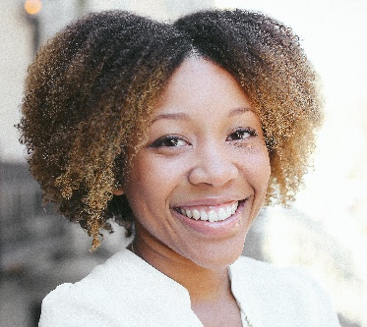
“Maxie” Ashley Maxie-Moreman, M.Ed./M.A.
Maxie is a fourth-year doctoral student in the Counseling Psychology program at the University of Miami (UM). She served as a program co-coordinator for the Kulula Mentoring program from 2016-2019, co-chair on the Early Scholars Committee for the Caribbean Regional Conference of Psychology from 2017-2019, and as co-chair on the Student Engagement Committee for the Intergroup Dialogue Working Group at UM from 2018-2019. Maxie is currently completing advanced practica at the Children’s Hospital of Philadelphia and at Academia Antonia Alonso Charter School. She also serves as an editor on the Student Editorial Board for the Collaborations Journal at UM and is a recipient of the John C. Mitchell Dissertation Fellowship. Lastly, Maxie is co-owner of Adventures of Bray LLC, a children’s picture book series, which centers Black children and promotes ethnic and racial identity development.
Maxie earned her B.S. in Psychology from the University of Florida and her M.Ed. and M.A. in Psychological Counseling at Teachers College, Columbia University.
She is interested in research examining the interaction between ethnic-racial identity and academic outcomes for Black and Latino adolescents in the US. She is also interested in intergroup dialogue regarding social identities.

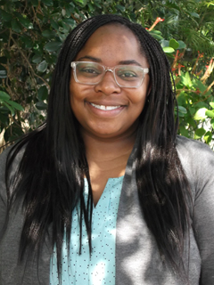
Dorothy Addae,
B.A.

Dorothy Addae, B.A. Dorothy joined CRECER in 2013 and is a doctoral student in the Counseling Psychology Program at the University of Miami. Dorothy’s work with CRECER has included assistance with the Day of Dialogue event, as well as coordinating the Kulula Mentoring Project and the Strong Roots Caregiver Program. Dorothy’s international background contributes to her passion and research focus. Her interests center around the immigration experience, acculturation, and migration policy. In addition to the adjustment and well-being of recent arrivals, Dorothy is interested in the experiences of Third Culture Kids and the success of international students in higher education. Dorothy desires that her work and career will serve immigrant populations in various contexts through psychologically informed practices, research, and consultation.

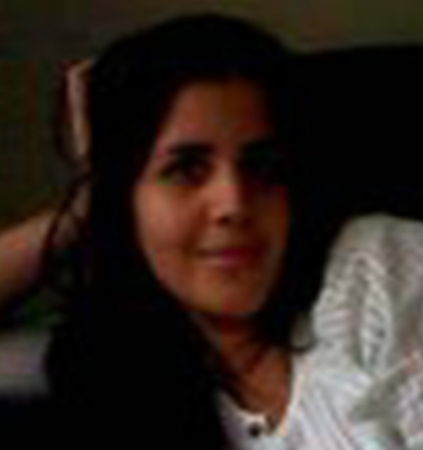
Noris Rio,
B.A.
Noris is a third-year doctoral student in the Counseling Psychology program at the University of Miami. She currently serves as program coordinators for both the Kulula Mentoring program and Evaluation for Breakthrough Miami project.
She earned her BA in Psychology at the University of Miami with a minor in Foreign Languages (French & Italian). During her undergraduate career she worked as a research assistant at the UM Mood and Anxiety Disorders lab.
With a mix of Dominican and Mexican roots, her research interests are focuses on issues of cultural diversity in the mental health profession. She wants to explore how culture influences perception about mental health service utilization, and the field in general

Recent Graduates

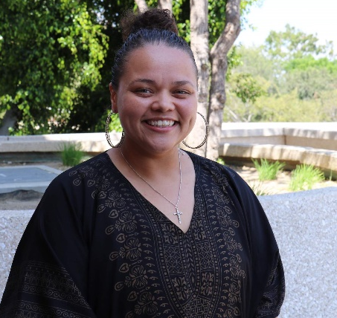
Amina Y. Simmons,
Ph.D.
Amina Y. Simmons is currently a Clinical Fellow at Arizona State University Counseling Services (ASU CS) in Tempe, AZ where she is completing her postdoctoral hours for independent licensure as a Counseling Psychologist. Amina completed her doctoral internship at California State University at Long Beach (CSULB) Counseling and Psychological Services (CAPS) in August 2019. In May 2019, she successfully defended her grant-funded dissertation, “African American Women’s Experiences of Race-Based Traumatic Stress.”
During her time in the Counseling Psychology program at the University of Miami, Amina served as a member of the CRECER research team for four years (2014-2018). Her roles included running the Kulula Mentoring program, leading Day of Dialogue for women’s wellness, mentoring first-year graduate students, and serving as the team lead for program operations/logistics including management of grant funds.
As a clinician, Amina works primarily within university counseling centers (UCCs)where she serves academic populations through her integrated style. Combining the core principles of Relational Cultural Theory (RCT) and the short-term interpersonal model of Time-Limited Dynamic Psychotherapy (TLDP), Amina provides mental health consultations, individual and group therapy, and participates in outreach with campus and community partners.
Amina’s research and clinical interests strive to center the well-being of women from the African diaspora, with a special focus on Black American women and girls. Recently, Amina co-authored a facilitator guide for a Black women’s support group, Sisterfriends, with the group’s founder, Dr. Pamela Ashe. Amina is expanding Dr. Ashe’s work with Sisterfriends​ to start additional groups on two college campuses in Arizona, and train other Black women leaders to facilitate ​Sisterfriends​ groups in their communities. For more about Amina’s commitment and passion serving Black women and girls visit her professional website: ​www.sistahsspeak.com​.
In December 2019, Amina will graduate with her doctorate in Counseling Psychology from the University of Miami, and she hopes to continue at ASU CS as a senior staff psychologist.

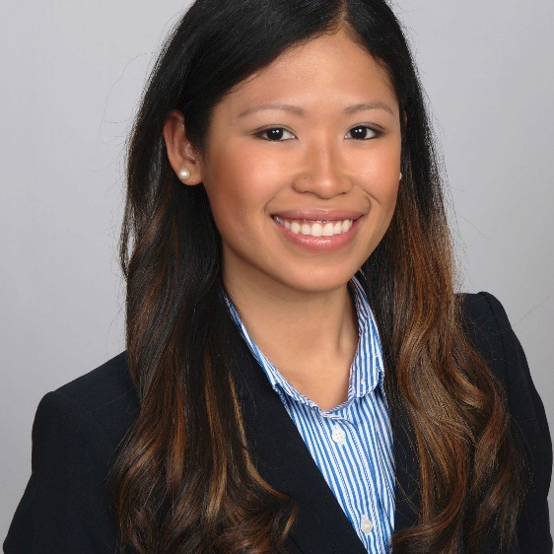
Kimberly Ho Misiaszek,
Ph.D.
Kimberly Ho Misiaszek is a recent graduate of the counseling psychology doctoral program at the University of Miami’s School of Education and Human Development. Her research seeks to understand and improve the psychological health of ethnic minorities and immigrants. Children and families with trauma and substance abuse histories, as well as behavioral, emotional, and developmental disorders have been the foci of her clinical work. She completed her predoctoral internship at Yale School of Medicine's Child Study Center, with an emphasis in trauma and children, and is now completing her postdoctoral fellowship there. She earned her M.A. in Mental Health Counseling and Wellness from New York University and a B.Sc. in Communications with a double major in Psychology and Public Relations from the University of Miami. A student of classical ballet since age 5, she also holds an advanced levels certificate of ballet through the Royal Academy of Dance and has performed throughout the island with Jamaica’s Movements Dance Company.
CONTACT US
Dr. Guerda Nicolas nguerda@miami.edu
Monique C. McKenny mcm370@miami.edu
Esprene Liddell-Quintyn exl500@miami.edu
Marisol Meyer mxm2560@miami.edu
Ceewin N. Louder cnl54@miami.edu
“Maxie” Ashley Maxie-Moreman adm174@miami.edu
Dorothy Addae d.addae@umiami.edu
Noris Rio n.rios1@umiami.edu
Dr. Amina Y. Simmons a.simmons4@miami.edu
Dr. Kimberly Ho Misiaszek k.ho2@umiami.edu

Program updates

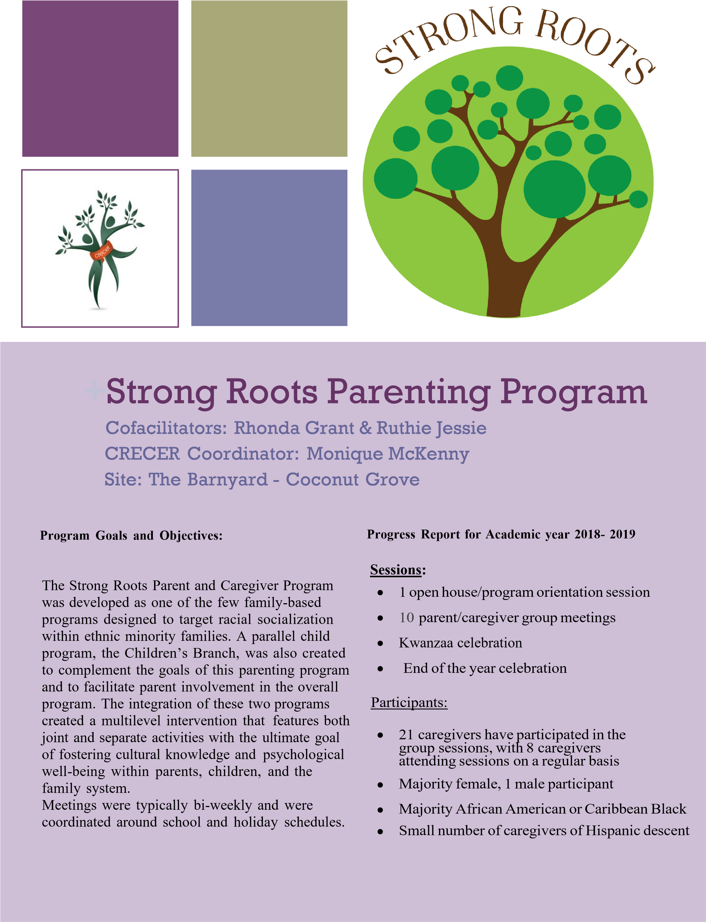

Strong Roots Academic Year 2018 – 2019
Curriculum:
Caregiver sessions were facilitated by two cofacilitators, one of which is a veteran Strong Roots participant and the other who is a parent rooted in the community and a previous Strong roots participant. Caregivers discussed experiences with discrimination and how they have chosen to talk with their children about such issues (Module 1: racial socialization), how they effectively cope with parental stress (Module 3: well- being), and navigating the local education system to advocate for their children's support and services (Module 2: communication) Caregivers and family structures varied with participants who are fathers, grandfathers, grandmothers, godfathers, as well as an adoptive father.

Major Highlight:

This year Strong Roots held its first father led parent group. While all parents were still welcome to attend, the session sought to amplify the voices of fathers’ parenting experiences. One Strong Roots father led the recruitment of fathers and coordinators and facilitators worked together to organize the agenda. Fourteen fathers attended the meeting sharing the unique experiences and challenges fathers face. Many participants called for an annual iteration of the fathers’ group, and multiple fathers later attended Strong Roots meetings.

Participant Feedback:
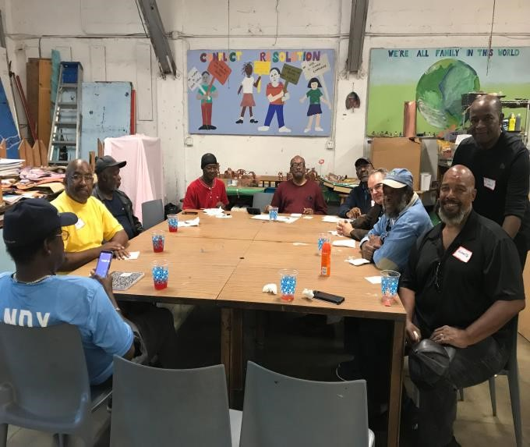
Participants expressed gratitude for the safe space that Strong Roots provides for parents to discuss relevant issues to parenting and issues specific to the West Grove community. Caregivers stated that just having a consistent space to join together was therapeutic. Many of the attending parents attended consistently, allowing for the group to build a rapport amongst one another.

Coordinator Reflection:
" I think Strong roots went really well this year. After some strong recruitment, attendance in the group picked up. I was especially impressed by what were able to accomplish with the men’s group. I think it gave us a chance to invite more parents if they come next year. I also appreciated the opportunity to collaborate with the kids in Kulula at the end of the year celebration. This is my second year as a facilitator, and I felt really comfortable doing it the second time. I was more comfortable recruiting parents for the meeting and Miss Ruthie, my co facilitator, contributed to the conversation during the meetings. Next year, I look forward to integrating more of the men from the men’s groups into our normal sessions to get some dialogue between fathers and mothers.”

Lessons Learned:

- Caregivers participation relies heavily on constant communication from facilitators and coordinator
- Caregivers are seeking information that addresses the intersectionality of their children, including gender socialization.
- Current events and local issues strongly impact the discussion of the group. Incorporating some time for these issues and how parents navigate them could be helpful.
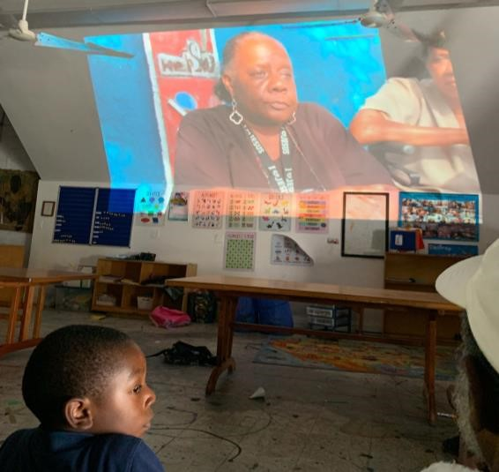

Future Directions:

Cofacilitators will participate in a two-day training retreat to reinforce psychoeducation and research underlying the modules of Strong Roots. Cofacilitators will also receive training on how to best manage the group and strengthen interpersonal skills to support them in guiding the conversation.
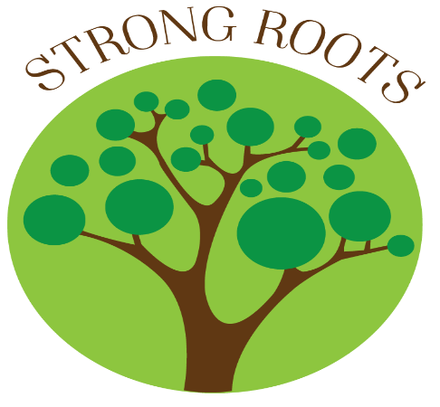

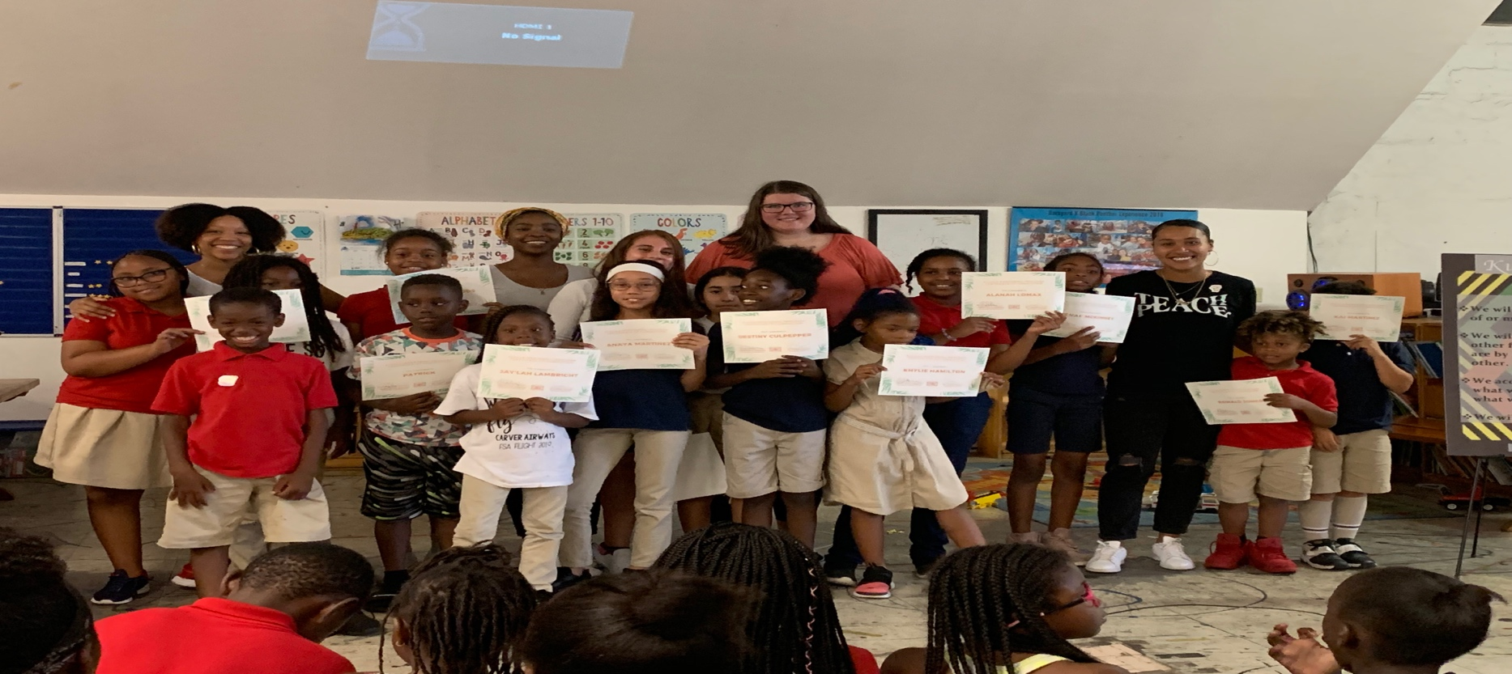
Kulula Mentoring Program

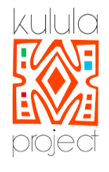

OVERVIEW

O
Project Co-Coordinators:
Maxie Moreman & Marisol Meyer
Kulula took place at the Barnyard Community Center for 16 sessions during the Fall 2018 and Spring 2019 semesters. A total of two Counseling Psychology Ph.D. students at the University of Miami served as co-coordinators of the mentoring program and supervisees of the Kulula mentors during the Fall semester, and in the Spring semester one coordinator due to a conflict in the second coordinators class schedule. A total of seven mentors from the University of Miami (six undergraduates and one alumna), implemented the program, which ran weekly for an hour on Thursday evenings. Of the children signed up to participate in October, there has been an average weekly attendance of 12 mentees. The mentees were divided into four smaller groups or jamaas (Swahili term for group or family). Mentees demographics include: 67% females and 33% males, ranging from kindergarten to 6th grade.

Meeting Routine
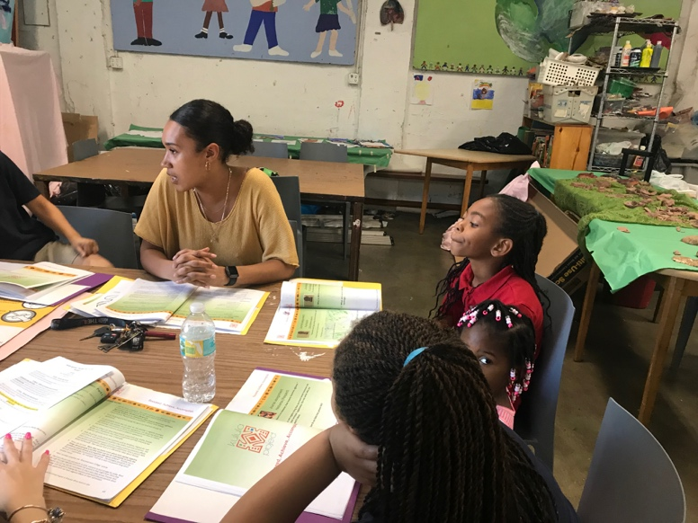
At the beginning of every Kulula meeting, all the mentors and mentees gather together in a large circle, to perform the opening ceremony of watering the tambiko (Swahili for libations) plant. This ceremony serves as a unifying start to the Kulula meeting. The plant signifies the growth the mentees and mentors hope to gain through the program and their acknowledgement of things they’re thankful for that have contributed to their growth thus far. Each individual takes a turn watering the plant and responding to prompt, “what are you thankful for?” Then, mentees and mentors work in their respective jamaas for 30-40 minutes on the curriculum, joining as a group to close by singing the “I Love Myself” song together.
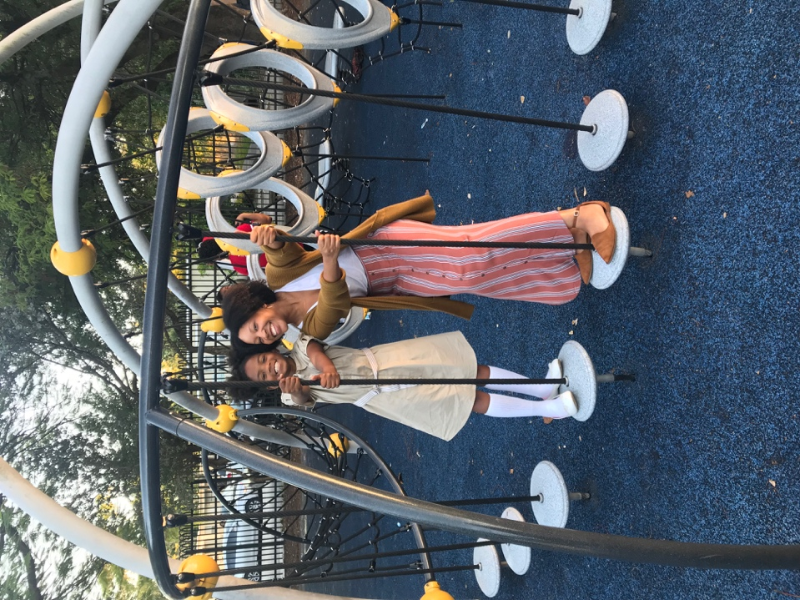
On a weekly basis, the mentors and program co-coordinators gather for a post Kulula debrief to discuss any behavior issues, concerns, or updates for the coming week. Monthly, the mentor group comes together for a Kulula family dinner. Dinners include a time for fellowship and team building and serves as a space to discuss the mentees progress, reflect over the past month’s meetings, and prepare for the next month.

Curriculum & project
Kulula’s Afrocentric based curriculum focuses on social, identity, and academic development. The 5 modules throughout the curriculum address the following questions: “Who Are The People In My Life?”, “Where Am I From?”, Who Am I?”, and “Who Do I Want To Be?”.
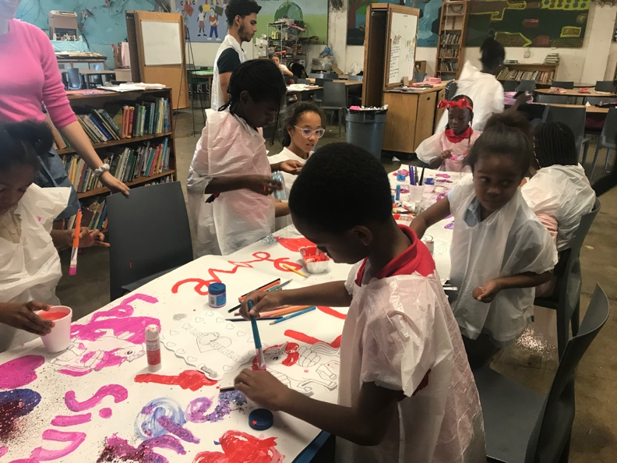
Each jaama began with the 1st module “Who Are The People In My Life” which encouraged the mentees to examine the relationships in their lives. The 2nd module, “Where Am I From?”, prompted mentees to complete journal activities and discuss what they believed were some positive and negative elements in their relationships, where members of their family live, and their knowledge of their community and family history.

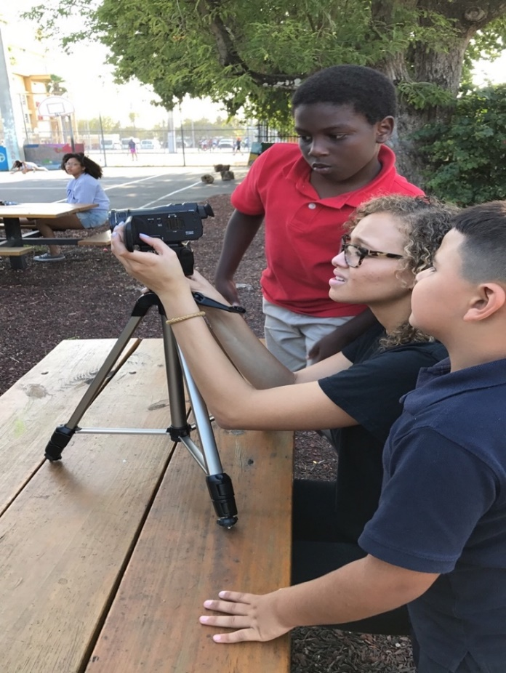
The 3rd module, “Who Am I?”, encouraged the mentees to examine the perceptions about themselves phenotypically, including standards of beauty, negative judgment, and self-esteem. Other projected module(s) for the Spring 2017 semester included: “Who Do I Want to Be?” Mentees completed journal activities and discussed positive and negative images of themselves and representation in the media. Mentors emphasized building positive images of self through creation of self-affirming collages and encouraged future-oriented discussions (i.e. deciding to pursue college). Other themes and topics discussed included: leadership, achievement, values, and community change.

Kulula Mentors
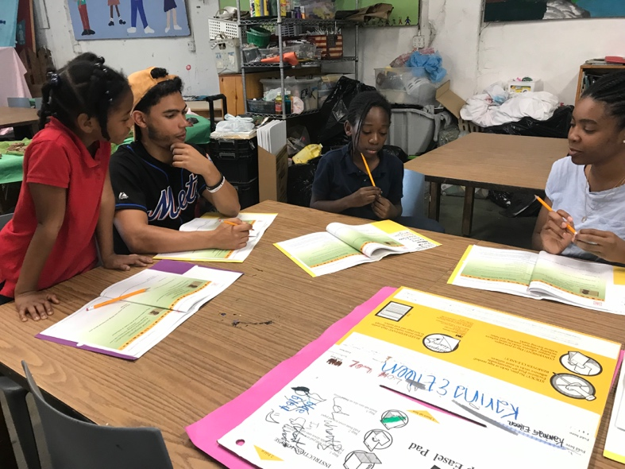
Kulula mentors consisted of seven University of Miami undergraduate students. Mentor racial and ethnic demographics included Black American, LatinX, White American. Mentor genders included cis-gendered females and one cis-gendered male.
Data collection takes place at the beginning and end of the academic year to assess any changes in racial identity, racial socialization, self-efficacy, and feelings of social support. In the 2016-2017 academic year, under the supervision of the PI, the project co-coordinators developed a brief qualitative version of the original quantitative evaluation measures that was more developmentally appropriate for the elementary aged students who were seeking participation. More specifically, the newly established measure was revised to account for a broader age range of students (e.g. kindergarten through middle school), participant fatigue, and utilizes developmentally appropriate language.
Literature on the Adolescent Racial and Ethnic Socialization Scale (ARESS; Brown & Krishnakumar, 2007), the Multi-Ethnic Identity Measure (MEIM-R; Phinney & Ong, 2007), the Self-efficacy Scale (SES) for Children (SEQ-C; Muris, 2011), and the Child and Adolescent Social Support Scale (CASSS; Malecki & Demaray, 2002), informed the development of the new qualitative measure to assess participants: basic demographics, knowledge about race and ethnicity, social support, and academic self-efficacy.

Coordinators are now taking further steps to revise the Kulula curriculum. Coordinators and other CRECER research team members will be meeting during June 2019 during the Kulula Theory of Change Retreat to refine the mission, goals, and interventions in the Kulula mentoring program. Coordinators plan to submit updates to the IRB in the Fall of 2019 and pilot both revised curriculum and measures during Kulula 2019-2020.

Kulula Events
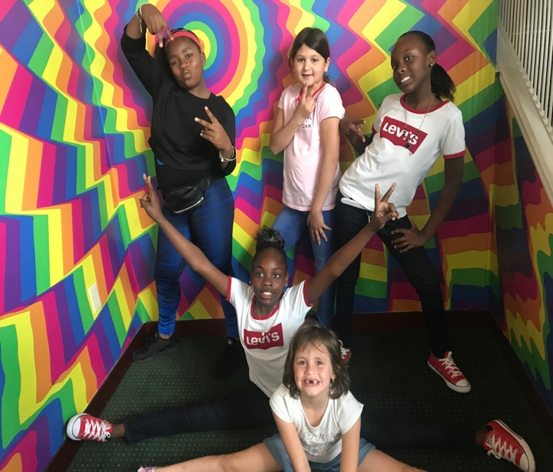
Major events held within the Kulula program this year included two celebrations, the Kwanzaa Celebration and the End of the year celebration. Both were a huge success and brought out Kulula mentees, mentors, parents, and community members. Additionally, the Kulula Program was able to embark on a field trip to enjoy a performance by the Alvin Ailey dance troupe.
The Kwanzaa Celebration was held in December and featured a live presentation of what each of the seven Kwanzaa principles mean. Each jamaa was assigned one or two principles and, with the help of their mentors, mentees explained the meaning of their Kwanzaa principle to an audience by presenting visual art pieces (such as posters) and performance art pieces (such as short original song). Following the presentation of the Kwanzaa Principles, guests were invited to sign pictures of mentors and mentees with kind words and affirmations.
The field trip to watch the Alvin Ailey dance troupe took place in February and provided Kulula mentors, mentees and family of mentees to enjoy a dance performance celebrating African American heritage. Following the field trip, mentees and mentors discussed key take-aways from the experience. Mentees could barely contain their excitement while watching the show and expressed the deep joy they experienced while watching the performance during the debrief with mentors.
The End of the Year Celebration brought focus to the youth’s civic engagement project on gentrification. Mentees performed a short show they had created to demonstrate their knowledge of gentrification to their audience. This event both celebrated members of the community while challenging us all to think about what we could do to better serve our neighborhood. Following this celebration, a film screening was held to present a video created by all participants in the Kulula program to better understand and reflect on the impacts of gentrification in the community of West Coconut Grove.

Civic Engagement Project
The civic engagement project is the last major aspect of the Kulula curriculum. It challenges the mentees to manifest what they have learned throughout the year on relationships, service, and pride into a project that will uplift and empower their own communities. This year, our mentees decided to focus their energies to address gentrification as experienced their community.
To tackle such a complicated subject, mentees and mentors collaborated to create a mixed-media project. Mentors presented a lesson on gentrification to all Kulula mentees in order to ensure everyone had a deep understanding of gentrification. Younger mentees were able to then create art pieces expressing their feelings about gentrification in their neighborhood following this lesson. Older mentees chose to work together to write and perform a show about gentrification to both demonstrate their learning and educate those (e.g. younger Kulula mentees) who might struggle with this conceptually dense idea. Aiming to reach a large audience, the mentees proposed that they create a video the incorporates all the dimensions of their project. The video includes the mentor lecture on gentrification, the mentees performance of gentrification, and finally, interviews conducted by the mentees with various members of the neighborhood. With the help of their mentors and equipment from the Digital Media Lab at the University of Miami, the mentees researched, acted in and directed their own feature film.
Following the End of the Year Celebration, a film screening was held where the mentees’ parents and family could see them on the big screen. The mentees showed great insight as they explained complex concepts like capital, culture, and change, and how these concepts interact in the gentrification process. This film will be shared with the Barnyard community and on the UM CRECER website.

Additions and Changes from 2018 – 2019
This year the Kulula coordinators decided to add several new components to the Kulula program. Mid-year the Kulula coordinator developed a hybrid jeopardy and family feud review game in which the mentees were asked questions related to curriculum content. The mentees thoroughly enjoyed this activity and did well with the review, as evidenced by their thoughtful and accurate responses to questions.
Additionally, a peer mentor component was added to the program. Four peer mentors were chosen, and they were tasked with helping peers during sessions, modeling appropriate behavior, as well as creating skits and facilitating interviews for the civic engagement project. Peer mentors responded well to their responsibilities and one peer mentor who had some behavioral issues prior to this appointment made significant gains in her behavior during sessions.

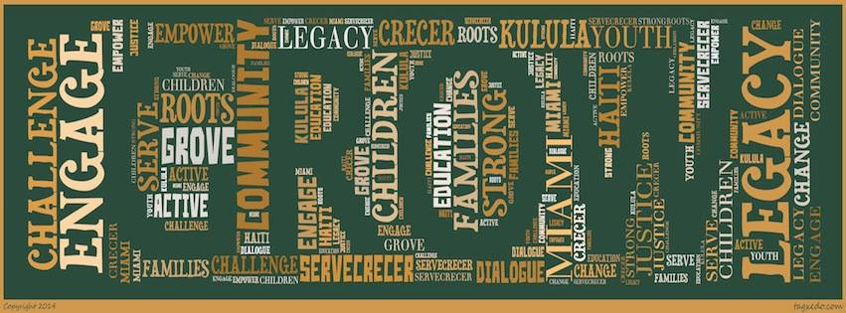
thank you!
11th Annual Day of Dialogue
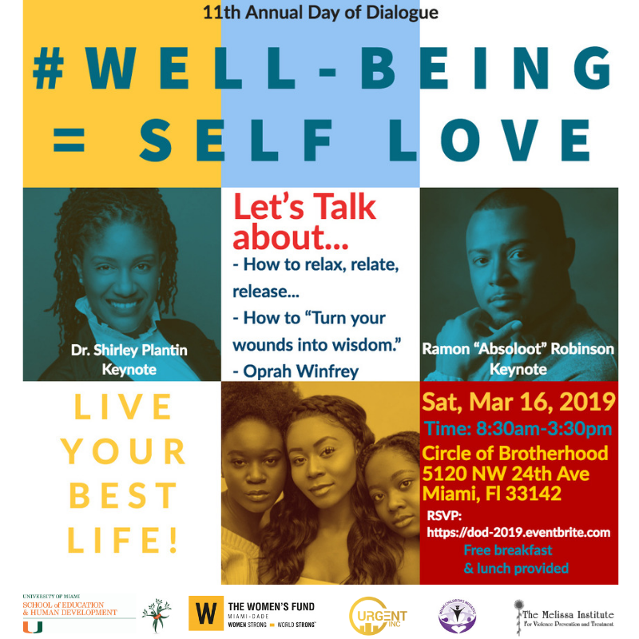
DAY OF DIALOGUE
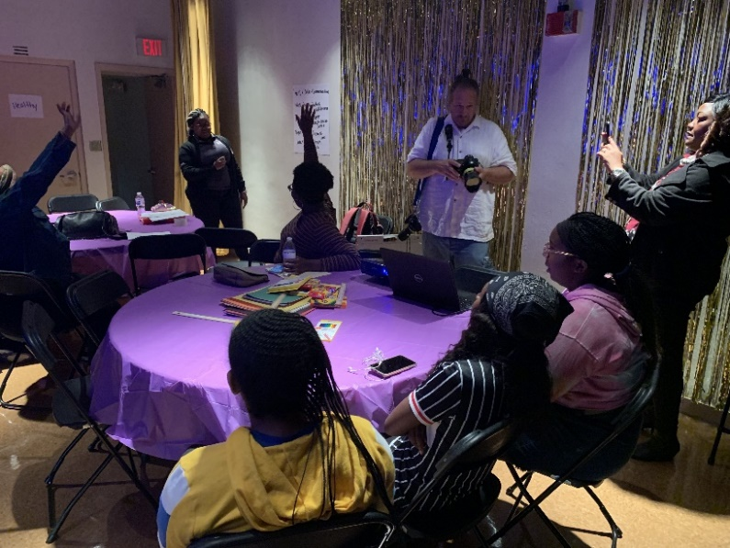
Coordinator: Esprene Liddell-Quintyn
Date: March 16th, 2019
Theme: Are you living your best life? #Well-Being = Self Love
Location: The Circle of Brotherhood
Community partners: Four community partners participated in DOD 2019: Miami Children’s Initiative, Women’s Fund, Melissa Institute and Urgent Inc.
Budget: Breakfast: $541.70
Lunch: $681.80
Supplies:13.72
Rationale:
Often, scholarly endeavors about community-based work focus narrowly on methodology regarding implementation of interventions or outcomes of proposed projects and partnerships. While this work is valuable, it seems that there may be an integral piece of the process that academics, organizers, and communities can easily overlook. The building of partnerships is the cornerstone of community work, yet rarely do we see scholars talking about what that process looks like. This process of bringing community entities that often have very little contact with one another, although they serve many of the same community members is about both intentionality and careful facilitation of a dialogue.

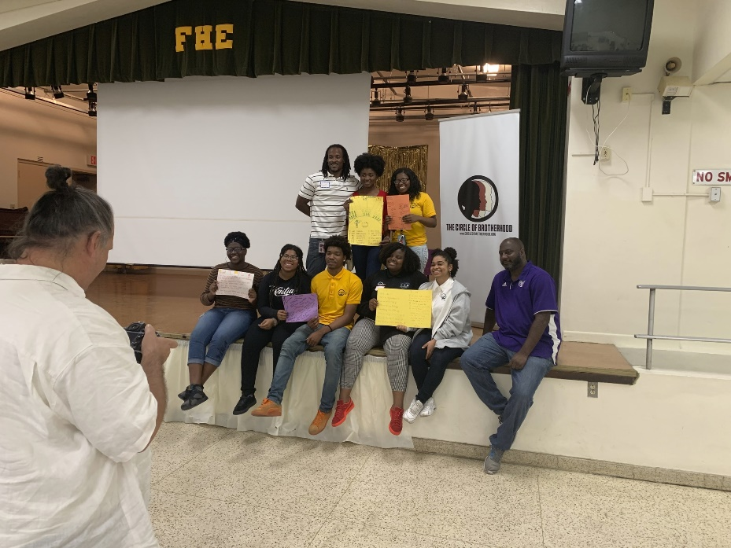
Overview of the Day of Dialogue: Day of Dialogue is a community driven event that the Challenging Racism and Empowering Communities through Ethnocultural Research (CRECER) team has facilitated in Miami since 2006. Started at Boston College and moving to the University of Miami, under the guidance of Dr. Guerda Nicolas, Day of Dialogue provided community organizations with the opportunity to come together to both identify and take action to address the needs of the community. Seven dialogues have been hosted in Miami, with various topics including: racism, tolerance, micro and macro aggression, promoting youth engagement, Native American communities, building bridges across cultures, and addressing the needs of Blacks in Miami. This year, the collaborative partners hosted the eleventh day of dialogue focused on youth health and well-being.
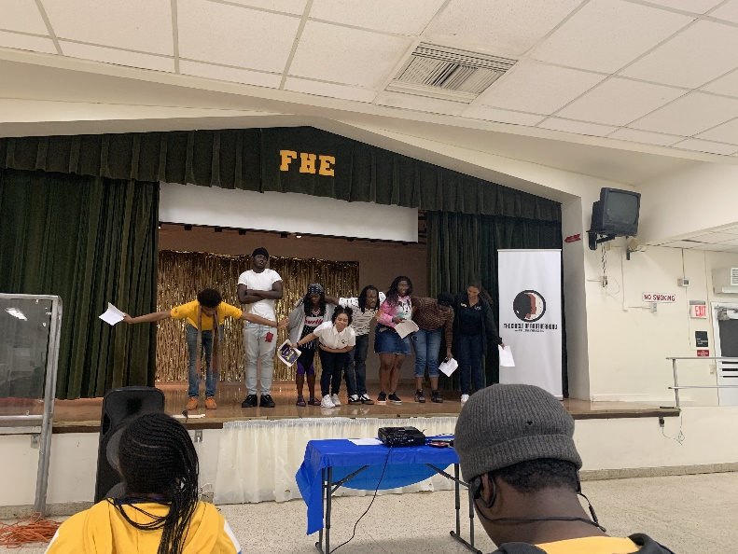
Planning Phase: Meetings were held at least once a month between October 2018 and February 2019 with community partners and youth ambassadors. Community partners were members of a core committee responsible for choosing the theme for the event, tentative topics for breakout sessions and the target population for this year’s DOD. Since community partners chose to center this community event on youth, each community partner selected 2-3 youth ambassadors who then became members of a sub-committee. The sub-committee reviewed the list of predetermined topics, identified topics they wanted to learn more about and generated a list of additional topics they wanted to discuss. During the planning meetings, youth ambassadors finalized a list of topics focused on consent & love, family planning, life planning, mental health awareness, self-awareness, dating violence and cyber safety. While community members from the core committee volunteered to facilitate breakout sessions for some of the topics and reached out to other community partners who served as facilitators for the breakout sessions. In total four community partners facilitated breakout sessions Project Dove, Miami Children’s Initiative, Planned Parenthood and Urgent Inc.
Event Day: During our eleventh Day of Dialogue, we held discussions on youth health and well-being. The day began with a keynote address by Dr. Shirley Plantin who shared a vibrant and engaging presentation on understanding the backstories on youth who engage in youth violence. Following this session, there were four breakout sessions on love and consent, dating violence and cyber safety, life planning and mental health awareness and family planning. After lunch, youth showcased their talents in several artistic performances which included acting in skits, reciting poems and singing songs that each delivered inspirational messages related to managing and maintaining a healthy physical and mental well-being. At the end of the day, all youth and adults gathered for a fishbowl session to share thoughts and nuggets from the breakout sessions they attended.
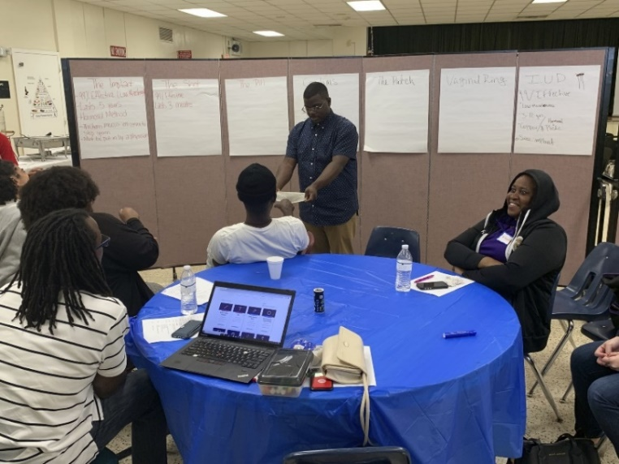
Lessons Learned: There were internal changes within some community organizations which affected their participation in the planning and execution of Day of Dialogue. Due to this, some immediate changes were made during the planning phase to adapt to these changes by drawing on the strength and capacity of the remaining community partners who all ensured that tasks and responsibilities were fulfilled so as to make DOD 2019 a success.
Future Directions: During our post reflection debrief session, community members called for a larger group of community organizations to get involved in DOD. In Fall 2019, community partners will meet to discuss ways to engage and reengage community partners within the local Miami area and will strategize on ways to invite additional community partners to participate in discussions around central issues affecting community members.
Meeting Agenda
11th DAY OF DIALOGUE
March 16th, 2019

8:30 - 9:00 Continental Breakfast

9:00- 9:15 ASSEMBLE IN MAIN AREA

9:15 - 9:30 General Introduction
      - Dr. Guerda Nicolas & Esprene
      - Community Partners
      - Youth Ambassadors
9:30 -9:50 Moderator: Khayla
Keynote Speaker- Dr. Shirley Plantin
9:50 – 10:10 Keynote Speaker- Absoloot (Ramon Robinson)

10:10- 10:15 INFORMATION SESSION

10:15-10:30 BREAK

10:30-11:20 Consent & Love – Planned Parenthood
Family Planning – Planned Parenthood

11:20- 11:25 TRANSITION

11:30- 12:20 Life Planning, Mental Health and Self Awareness- Urgent Inc and MCI
Dating Violence, Cyber Safety- Project Dove

12:30:1:30 LUNCH

1:35 - 2:35 Creative Arts Segment (Co-chairs: Ashley & Tamainica)
Poem—Maurisha
Rise Up- Khayla & Jas
Short film- Urgent Inc
Skit- She kept her bra on – Urgent Inc

2:40- 3:20 FISHBOWL
Co facilitators: Maurisha, Duvernot, Jasmine

3:20 – 3:30 Closing Remarks- Kaleem

Selected Articles and Books
from the CRECER Lab

Thompson, C.E., & Nicolas, G. (10 books series contract; 2017). Pan-African Psychologies. New York: NY: Palgrave Macmillan
Nicolas, Guerda & E. F. Thompson, Chalmer. (2019). Racialized Violence in the Lives of Black People: Illustrations From Haiti (Ayiti) and the United States. American Psychologist. 10.1037/amp0000453.
Streets, B., Nicolas, G., & Wolford, K. (2016). Pause…Before Rushing In: Examining Motivations to Help in Trauma Impacted Communities Internationally. International Research and Review, 4 (2).
Nicolas, G., Byer, K., & Ho, K. (2015). Guiding Principles for Implementing Mental Health Programs Internationally. International Journal of Culture and Mental Health. DOI:10.1080/17542863.2014.996237
Streets, B., Nicolas, G., & Wolford, K. (2015). Pause...before rushing in: examining motivations to help in trauma impacted communities internationally. International Research and Review, 4(2), 15-31.
Nicolas, G., Byer, K., & Ho, K. (2015). Guiding principles for implementing mental health programs internationally. International Journal of Culture and Mental Health, 8(4), 446- 457.
Nicolas, G., Bejarano, A., & Lee, D. (Eds.). (2015). Contemporary parenting: a global perspective. Abingdon, UK: Taylor Francis (Routledge Press).
Nicolas, G., Wheatley, A., & Guillaume, C. (2014). Does one trauma fit all? Exploring the relevance of PTSD across cultures. International Journal of Culture and Mental Health, 8(1),34-45. doi:10.1080/17542863.2014.892519

